Small gifts. Big joy.

Pretty Presents by Scheurich

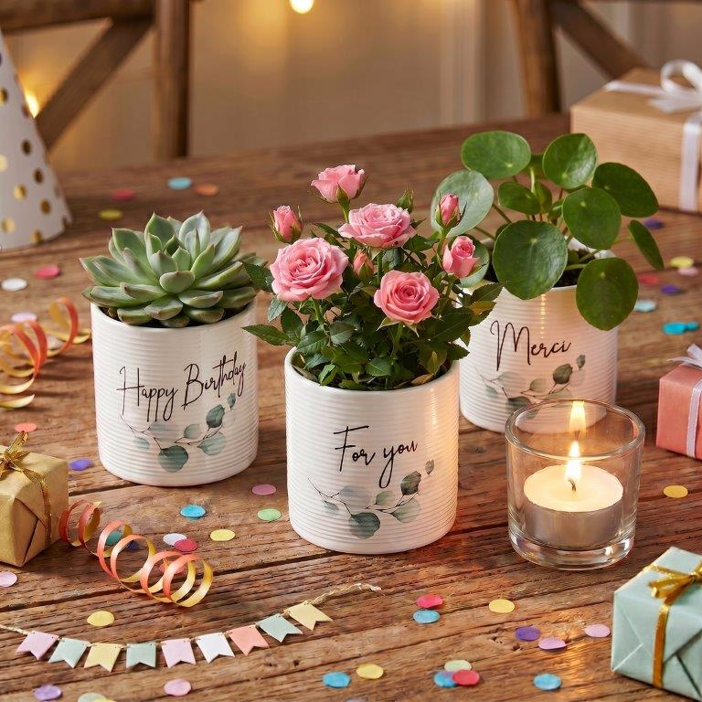
Say it with flowers: Scheurich extends the joy of a floral gift with the Pretty Presents mini cover pots and matching plants such as a succulent, indoor rose or pilea. The heartfelt message on the cover pot catches the eye time and again in everyday life, thereby enhancing the effect.

With Pretty Presents, Scheurich finds the perfect words for the most common occasions, combining a gift and a greeting card in one – Happy Birthday, For you or Merci. With Pretty Presents, gift-givers can express birthday wishes, a thank you or words of affection in a concise way. The understated charm of Pretty Presents complements the existing cover pots in the home décor of plant lovers.

Gifting with style: a clear, cylindrical shape meets longitudinal grooves reminiscent of high-quality paper textures, onto which the heartfelt message and a single sprig of eucalyptus are printed. It looks as though these have been handwritten and hand-drawn – this is what gives the range its personal charm and emphasises its greeting card character.

Pretty Presents are made in Germany and 100 per cent waterproof.

Available sizes:
Cover pots Pretty Birthday, Pretty for you,
Pretty Merci: 7 and 9 cm

About Scheurich

Designed for Your Life.

The premium supplier of planters and innovative plant-related solutions is unveiling a new look and brand positioning – whilst maintaining the same high standards of quality. Over its nearly 100-year history, Scheurich has played a key role in shaping design trends. Today, Scheurich stands for far more than just ceramics: aesthetic products that bring a sense of well-being into everyday life. It is the people who define the brand – a family with a name and a history. Scheurich takes responsibility for today and for future generations.

