For cosy living spaces

Raw Timber and Raw Canvas by Scheurich

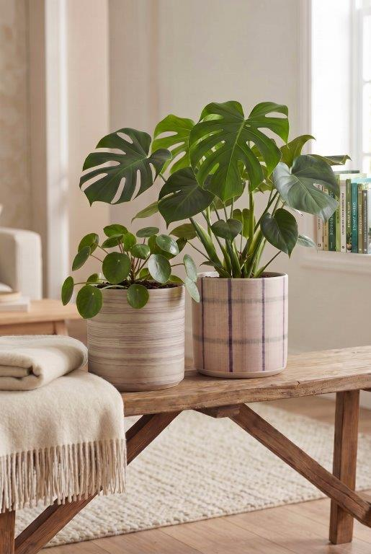
With their natural look, these two attractive designs from Scheurich could even give plants a run for their money. Raw Timber and Raw Canvas are reminders of cosy woollen blankets with a stylish weave – combined with a matt stone finish and a colour palette that blends seamlessly with the Scandi style, cosy cottage atmosphere or the green living trend.

Subdued colours are now everywhere in modern living: for example, in furniture made from light woods such as oak, birch and ash, as well as accessories like coarsely knotted rugs and plaids in off-white – and Raw Timber and Raw Canvas right in the middle of it all with bright green plants such as Monstera (Swiss cheese plant) and Pilea peperomioides (lucky money plant). A sight that brings relaxation!

Raw Timber and Raw Canvas are made using the high-quality Polyprint process: together with the timelessly beautiful cylindrical shape and the small rim at the bottom, Scheurich strikes the perfect balance here between organic charm and purist clarity. An arrangement of Raw Timber, Raw Canvas and plain-coloured cover pots expands the design possibilities for plant lovers.

The cover pots are Made in Germany and 100 per cent waterproof.

Available sizes:
Cover pots Raw Timber, Raw Canvas:
12, 14, 16 and 19 cm

About Scheurich

Designed for Your Life.

The premium supplier of planters and innovative plant-related solutions is unveiling a new look and brand positioning – whilst maintaining the same high standards of quality. Over its nearly 100-year history, Scheurich has played a key role in shaping design trends. Today, Scheurich stands for far more than just ceramics: aesthetic products that bring a sense of well-being into everyday life. It is the people who define the brand – a family with a name and a history. Scheurich takes responsibility for today and for future generations.

