Outdoor Living

Rigato by Scheurich

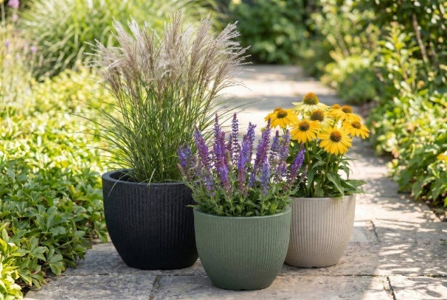
Plant enthusiasts are now styling their patios with the new Rigato range from Scheurich. The harmoniously rounded silhouette and gentle grooves complement lounge furniture settings perfectly and enhance the cosy feel that is becoming increasingly popular in outdoor spaces too.

For many people today, spending time at home means enjoying their own outdoor space in the summer. Scheurich’s Rigato range meets the resulting demands for planters in both appearance and quality. The grooved surface adds subtle depth and a sense of quality to the design, whilst the Garduro plastic is lightweight, UV- and frost-resistant, and made in Germany.

Rigato in Mangrove, Sand or Stony Black echoes the natural colour palette of the surroundings and leaves all options open for plant enthusiasts. A coneflower (Rudbeckia) looks just as harmonious in it as woodland sage (Salvia nemorosa) or Chinese silver grass – Scheurich once again provides the base that can be filled with flowers to suit your mood.

And because the lines between indoors and outdoors are becoming increasingly blurred, Scheurich has also fitted Rigato with a drain plug: this flexibly protects the plants from waterlogging or protects the floor in the living area when the planters are overwintering there. Outdoors, the plug is safely stored in the ‘parking position’ in the base of Rigato.

Available sizes:
Planter Rigato: 30, 40 and 47 cm

About Scheurich

Designed for Your Life.

The premium supplier of planters and innovative plant-related solutions is unveiling a new look and brand positioning – whilst maintaining the same high standards of quality. Over its nearly 100-year history, Scheurich has played a key role in shaping design trends. Today, Scheurich stands for far more than just ceramics: aesthetic products that bring a sense of well-being into everyday life. It is the people who define the brand – a family with a name and a history. Scheurich takes responsibility for today and for future generations.

