The Power of Texture

Rustic Clay by Scheurich

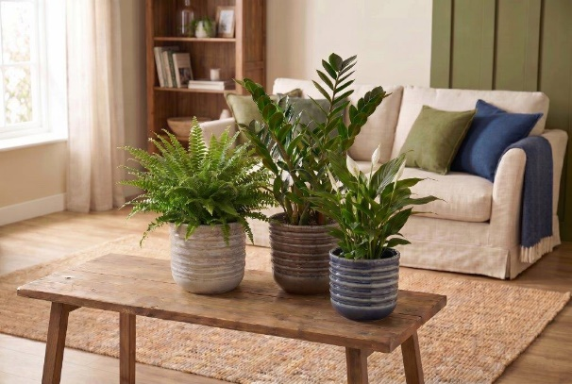
Authentic and beautiful, just like nature itself: Nordic Dusk, Raw Earth, Deep Fjord and Forest Moss captivate with their coarse texture in shades of beige, brown, blue and green, and a handmade look that truly lives up to its name: Deep grooves give the cover pots across the Rustic Clay range a distinctive signature and lend the living space itself a sophisticated robustness with a modern touch.

The glossy finish and rounded base create a soft-focus contrast to the rustic touch – Rustic Clay thus combines the best of both worlds: appealing to the touch and high-quality in design. And because rooms are meant to breathe, Rustic Clay features grooves of varying depths and numbers depending on the pot size. This brings visual dynamics to the room, and the surface with its handcrafted carved relief enhances this effect.

Anyone who sees Rustic Clay immediately thinks of an interior style featuring linen, wool and other natural materials. Rustic Clay looks particularly harmonious on darker wood furniture. Plant lovers need not worry about water stains: the cover pots are 100 per cent waterproof and are made in Germany. When choosing plants, you can draw on the full range of floral variety: sword fern (Nephrolepis), lucky feather (Zamioculcas) or peace lily (Spathiphyllum) look particularly good with Rustic Clay.

Available sizes:
Cover pots Forest Moss, Nordic Dusk, Raw Earth,
Deep Fjord:
13, 15, 18, 21 and 24 cm

About Scheurich

Designed for Your Life.

The premium supplier of planters and innovative plant-related solutions is unveiling a new look and brand positioning – whilst maintaining the same high standards of quality. Over its nearly 100-year history, Scheurich has played a key role in shaping design trends. Today, Scheurich stands for far more than just ceramics: aesthetic products that bring a sense of well-being into everyday life. It is the people who define the brand – a family with a name and a history. Scheurich takes responsibility for today and for future generations.

