Cylindrical shape, vertical relief

Scala by Scheurich

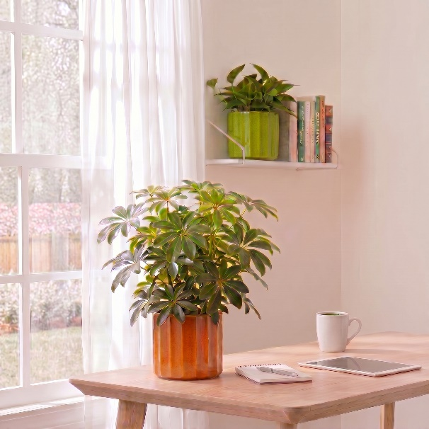
For a striking appearance: Scala by Scheurich is the timelessly beautiful cover pot range with a relief texture in various colour and finish options – from classically matt to glossy and silky-matt. Depending on the version, the distinctive longitudinal grooves create a different look that complements your personal interior style.

Sophisticated in Refined Cream, Grey, Green or Hazel: if you want your living space to radiate a soothing warmth and cosiness, then Cream, Grey, Green and Hazel are the perfect choices. Cream and Grey lend a special glow to modern rooms. With Green and Hazel, plant lovers can highlight their preference for understated style – a satin-matt finish is on-trend and looks particularly elegant. And Scala in Panna and Night Black offers a classic black-and-white look.

Light accents, glossy effects and plenty of ways to combine Scala make this cover pot a favourite: Cream and Grey immediately evoke the Scandi look. Complemented by Green, the trio fits perfectly into an urban jungle. ‘Welcome to the Cozy Cottage’ is the theme with Cream and Hazel. If you’re in the mood for retro, combine Green and Hazel. All four Refined variants can also be decorated to suit your mood. There are no limits to your imagination here. But there are limits to the watering can: Scala is Made in Germany and 100 per cent waterproof.

Available sizes:
Cover pots Refined Cream, Refined Grey,
Refined Green, Refined Hazel:
12, 14, 16, 19 and 21 cm
Cover pots Panna, Night Black:
12, 14, 16, 19, 21, 24 and 27 cm

About Scheurich

Designed for Your Life.

The premium supplier of planters and innovative plant-related solutions is unveiling a new look and brand positioning – whilst maintaining the same high standards of quality. Over its nearly 100-year history, Scheurich has played a key role in shaping design trends. Today, Scheurich stands for far more than just ceramics: aesthetic products that bring a sense of well-being into everyday life. It is the people who define the brand – a family with a name and a history. Scheurich takes responsibility for today and for future generations.

