Living with ease

Solido Pastels by Scheurich

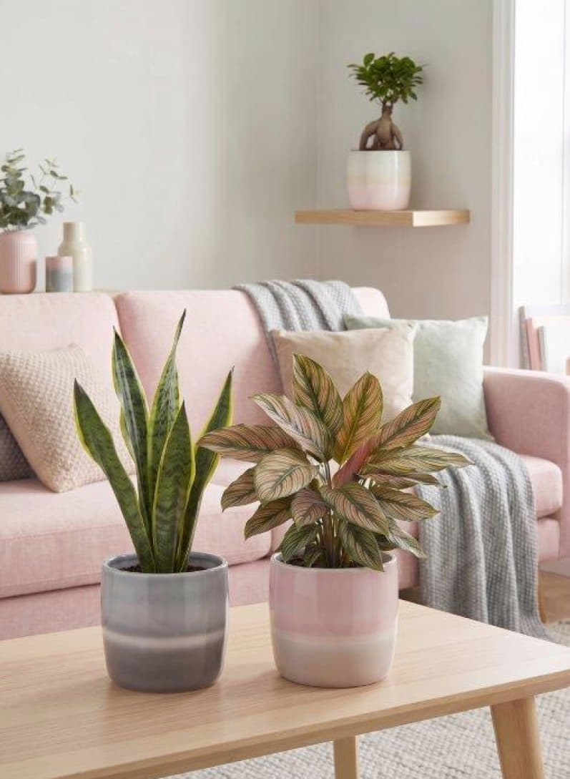
Pastel shades for Solido by Scheurich: with its soft colours, shimmering effects and focus on curves, Solido Pastels creates a particularly striking visual effect in any room. Welcome to a world of comfort where everyday life is left at the door.

Faded Rose, Faded Green and Faded Grey embody a lifestyle full of emotion and cosy aesthetics. With three delicately flowing colour gradients in rosé, green and grey, Solido Pastels captures the romantic look of the room – light woods and textiles in cream, pink or grey combine to create a high-quality interior style, into which the thick-walled design fits harmoniously. The light stripe adds a visual accent to the soft colour transitions and enhances the charm of the range.

Solido is popular – Scheurich therefore continually reinvents this timeless cover pot and, with Pastels, focuses on elegant restraint, which is harmoniously complemented by plants such as snake plant (Sansevieria), calathea and ginseng fig (Ficus Ginseng). Arranged together, Pastels adds an atmospheric touch to the Cozy Cottage. The combination of handcrafted shape and a glossy finish creates a harmonious balance.

Pastels is Made in Germany and 100 per cent waterproof.

Available sizes:
Cover pots Faded Grey, Faded Rose, Faded Green:
13, 15, 18 and 21 cm

About Scheurich

Designed for Your Life.

The premium supplier of planters and innovative plant-related solutions is unveiling a new look and brand positioning – whilst maintaining the same high standards of quality. Over its nearly 100-year history, Scheurich has played a key role in shaping design trends. Today, Scheurich stands for far more than just ceramics: aesthetic products that bring a sense of well-being into everyday life. It is the people who define the brand – a family with a name and a history. Scheurich takes responsibility for today and for future generations.

