Scheurich honours Mexican artist

Strong Women Edition

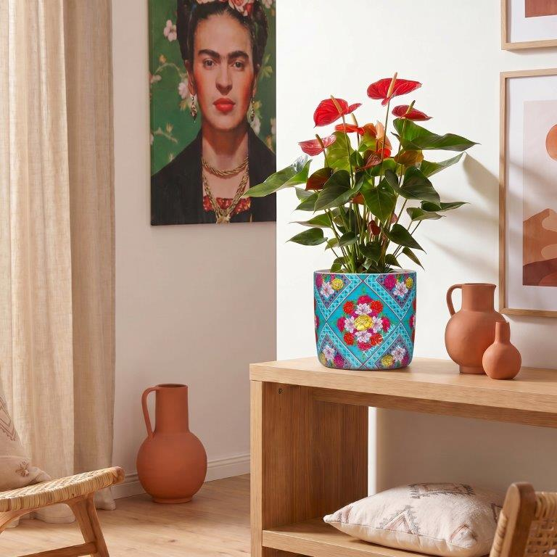
Frida Kahlo™ was an extraordinary woman: the daughter of a German photographer and a Mexican painter, she was forced to give up her dream of becoming a doctor following a life-changing accident at the age of 18. Kahlo rose to the challenge, reinvented herself and remains to this day a symbol of radical self-determination. She began to paint and became world-famous and acclaimed, not least for her self-portraits.

Scheurich is currently paying tribute to this great 20th-century artist with the Strong Women Edition and six expressive cover pots: powerful colours, portraits and floral motifs, which are just as inextricably linked to her work, embody the fascination of Frida Kahlo™.

This range brings art history and Mexican accents into your own home: Frida Flores and Frida Amor inspire with quotes from this passionate woman. Frida Turquesa and Frida Esmeralda complement the Strong Woman Edition with floral designs, whilst Frida Amarillo and Frida Rojo round off the tribute to Frida Kahlo™ with plain cover pots in yellow and red. Each plant pot is also adorned with Frida Kahlo’s signature.

Whether placed individually or in a colourful mix, these cover pots really come into their own in any home setting. Creativity is also encouraged when choosing plants: Flamingo flowers, Monstera 'Monkey Leaf' and a Calathea go particularly well with the Strong Women Edition. To perfectly capture the brilliant colour intensity of Frida Kahlo™, Scheurich produces the decorative cover pots in this series using the innovative, high-quality Polyprint process.

The Strong Women Edition is Made in Germany and 100 per cent waterproof.

Available size:
13 cm

About Scheurich

Designed for Your Life.

The premium supplier of planters and innovative plant-related solutions is unveiling a new look and brand positioning – whilst maintaining the same high standards of quality. Over its nearly 100-year history, Scheurich has played a key role in shaping design trends. Today, Scheurich stands for far more than just ceramics: aesthetic products that bring a sense of well-being into everyday life. It is the people who define the brand – a family with a name and a history. Scheurich takes responsibility for today and for future generations.

