My Style: Green Living

Urban Stripes and Jungle Leaves by Scheurich

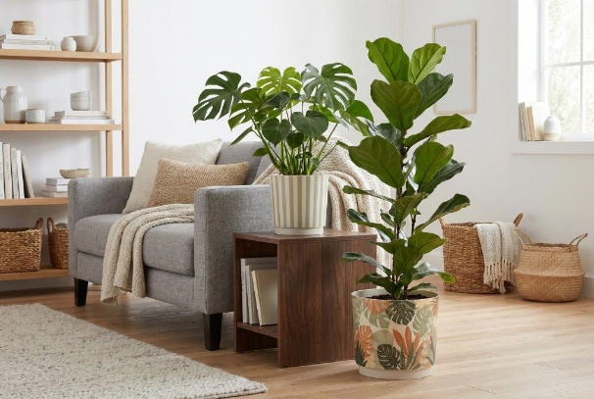
With Urban Stripes and Jungle Leaves, Scheurich presents the perfect balance between urban jungle and clean lines. Whilst the Jungle Leaves planter is printed with a lush leaf design, wide vertical stripes in sage green adorn the Urban Stripes planter. The uniform shape with a cream-white background ensures the two planters complement each other perfectly.

Nature is clearly a design statement here, rendered in high-quality Polyprint. The patterns themselves are just as on-trend as the matt finish. Scheurich knows that the urban jungle aesthetic is only too happy to continue growing in the homes of plant lovers. For added variety, the Plano planters in Matt Yellow, Matt Sage and Avorio are ideal. The plain colours can be beautifully combined with the patterns. Swiss cheese plant (Monstera) and weeping fig (Ficus lyrata) complement Urban Stripes and Jungle Leaves perfectly.

Scheurich is committed to a sustainable lifestyle and produces these trendy indoor planters from Reduro plastic in Germany.

Available sizes:
Planters Urban Stripes, Jungle Leaves:
13, 15, 18 and 21 cm
Planters Plano Matt Yellow, Matt Sage, Avorio:
13, 15, 18, 21, 25 and 29 cm

About Scheurich

Designed for Your Life.

The premium supplier of planters and innovative plant-related solutions is unveiling a new look and brand positioning – whilst maintaining the same high standards of quality. Over its nearly 100-year history, Scheurich has played a key role in shaping design trends. Today, Scheurich stands for far more than just ceramics: aesthetic products that bring a sense of well-being into everyday life. It is the people who define the brand – a family with a name and a history. Scheurich takes responsibility for today and for future generations.

